**Subsets**

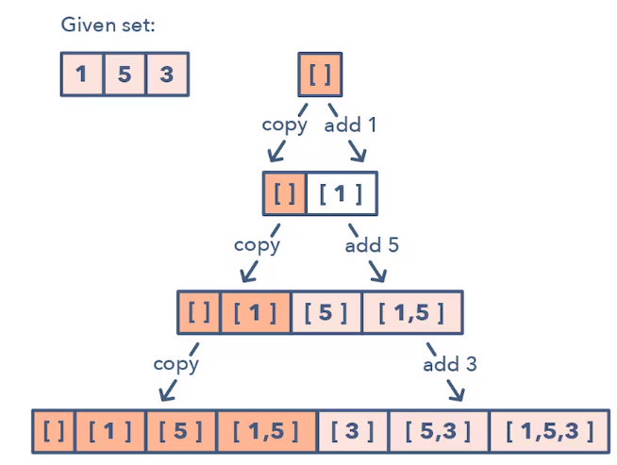

**Ways to Identify the pattern:**

* Problems where you need to find the combinations or permutations of a given set

**Common problems you use the sliding window pattern with:**

* Subsets With Duplicates (easy)
* String Permutations by changing case (medium)

**Broad Categories:**

* None.